How to SpeedUp WordPress Site Speed

You can't afford to waste a moment online. Speed things, particularly when it comes to loading period. In reality, if your WordPress site is sluggish and forces users to wait around for even a couple of seconds, you are likely to feel that the negative effects straight away. You can see rising bounce prices, diminished conversions, and bad search rankings. [How to SpeedUp WordPress Site Speed](https://kindlybeinformed.com/smart-ways-to-speed-up-wordpress-site-performance/) is not that easy. Learn here.

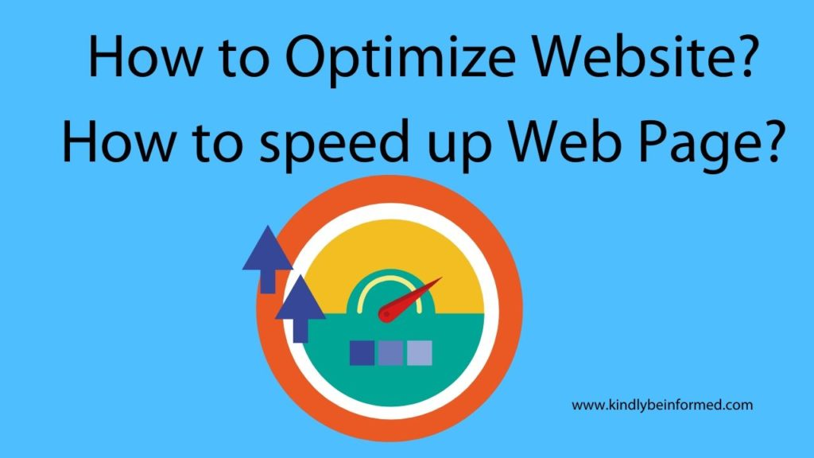

Fortunately, there are many things you can do to prevent these problems! WordPress as a platform offers lots of alternatives for optimizing your website in order to make it quicker and more reliable. In reality, even when you're not a specialist in website optimization, then you can use several methods to improve your site's loading times fast.

Within this guide, we'll explain everything you can do in order to boost website performance and optimize for speed. We'll also look at how it is possible to diagnose problems that slow down your website and, more crucially, how to repair them. There is a lot to cover, so let's get started!

**Why Getting a Fast Website Is Essential**

Things have changed a lot since the beginning of the internet. Today's users expect considerably quicker loading times, and your site needs to live up to these expectations. In reality, making certain your site is quick and performs well is the very first of Google's four Internet Basics, and it's easy to see why.

The largest problem with getting a slow site is that your customers will frequently lose patience and leave. This negatively impacts your bounce rate, which reflects the number of visitors who click away after just seeing one page. Nearly half of users expect sites to load in two minutes or less, and 40% will leave a website if it hasn't loaded within 3 seconds. Additionally, a delay of just one second may result in a 7 percent reduction in conversions. 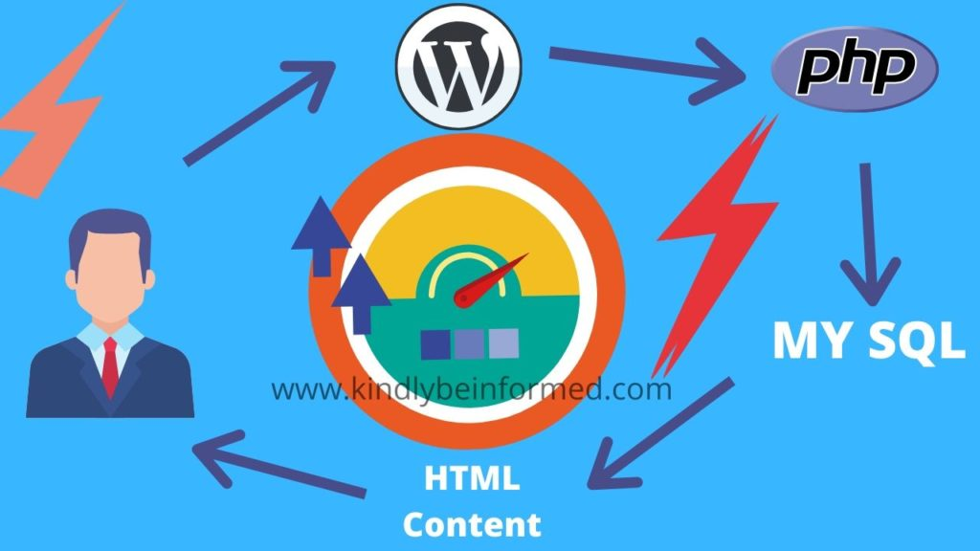

Those numbers may be startling, but they help demonstrate the value of keeping a quick, reliable site. If lost traffic and conversions are not persuasive enough, it's also wise to consider your website's Search Engine Optimization (search engine optimization ). **Speed is a factor Google** cares about, so slow webpages can lead to a decrease in your search positions.

Finally, you'll also need to be conscious of the effects of your site's rate across platforms. Since 2016, more folks are using mobile devices to surf the internet than desktop computers. That is almost two-thirds of humans on the planet.

This matters **SpeedUp WordPress Site Speed** because most mobile users are looking for a similar experience to what they'd get on a traditional computer. Almost half expect websites to load in less than 10 seconds.

You can follow suit and ensure that your site is fast enough to keep the user's experience welcoming. But, you'll first have to understand why your pages may not be doing as well as you'd like.

**Boost Your Website with DreamPress**

Our automatic upgrades and robust security defenses take server direction off your hands. And did we mention the lightning-fast load times?

Learn More

**What Makes Your Site to Slow Down**

You must now be completely aware of the negative effects long load times can have on your site. However, it is equally important that you understand the causes of a site in order to slow down at the first place. We are going to be looking in more detail at a few of the causes later on. At the moment, let's quickly run through a couple of the most common culprits.

The most probable cause of slow loading times and a lack of functionality is simply a poorly developed website. However, the hosting provider and strategy that you choose are also significant variables so you have to make sure you pick a quality web host for your site.

If your host is slow or adventures frequent downtimes, so will your website. We'll discuss how hosts and plans affect your site in more detail shortly, but it's worth repeating that choosing a quality host is a must. In addition, we suggest that you consider managed hosting, which makes sure that your website is quick, responsive, and dependable. Proven Tips To accelerate WordPress: How To Boost Loading time

**Use Latest PHP -- 7.0+**

This single switch alone could boost your Twitter rate by nearly 1.5x. The most recent one is PHP 7.4 which offers a substantial performance increase.

The PHP component is handled by your web-hosting business and either you can manually assess your existing version of PHP on which your WordPress website is running on, or you could simply request the client support:

If it is less than 7.0 (That is 5.6), you can ask them to upgrade to the most recent PHP version.

If you're using Bluehost hosting, then you are able to follow this tutorial to update Bluehost PHP version.

This single change alone can accelerate your WordPress site to a fantastic extent.

Many of us make a mistake by simply picking a local web-hosting provider to host our WordPress site. Normally, such hosting is recommended by our designer/developer or someone known in our circle.

Are they the best?

Well, your rate test could reveal exactly the same.

Do recall, you should pick only that hosting company that's well optimized for conducting WordPress blogs.

SiteGround is undoubted provides the top quality servers at the hosting category that's idle for most of us.

|  |
| --- |
| [Zakra WordPress Theme Review 2020](https://kindlybeinformed.com/zakra-wordpress-theme-review/) |
| [Hive WordPress Theme Review](https://kindlybeinformed.com/hive-wordpress-theme/) |
| [Astra – WordPress Theme Review](https://kindlybeinformed.com/astra-theme-review-wordpress/) |

Siteground Hosting for WordPress

If you are operating a business Site on WordPress or possess a professional blog, you need to get hosting from Kinsta.

Kinsta offers many advanced features which will straight away decrease the loading time of a WordPress website. Some of those features are:

Premium DNS

Kinsta MU (In-built cache)

Kinsta utilizes Google cloud infrastructure to host your WordPress website and this offers you the ability to pick from the plethora of information center choices.

If You're using WooCommerce platform, then just use these hosting:

SiteGround

Kinsta

[15 Best WordPress SEO Plugins](https://kindlybeinformed.com/best-wordpress-seo-plugins-tools/)

**Do not use too many WordPress plugins**

Among the most significant forces of WordPress is plugins, and some of you're so obsessed with this, which you're using more than 30-40 plugins on your blog. Well, not plugin is bad, and I've covered a fantastic write-up how many WordPress plugins you should utilize.

Try to **decrease the number of plugins on your blog** and regularly clean up your database. Advanced database cleaner plugin is able to help you do so in almost no time.

Ensure that you are using a minumum of one cache plugin on your site, and I am indicating **WP-Rocket plugin.** One thumb rule, get rid of obsolete plugins.

|  |
| --- |
|  |
| [15 Best Plugins for Accepting Bitcoin](https://kindlybeinformed.com/bitcoin-wordpress-plugin-cryptocurrency-payment/) |
|  |
| [11 Best WordPress Translation Plugins](https://kindlybeinformed.com/wordpress-translation-plugin/) |
| [30 Smart Ways to Speed-up WordPress Site Performance](https://kindlybeinformed.com/smart-ways-to-speed-up-wordpress-site-performance/) |
| [10 Best Fastest WordPress Themes](https://kindlybeinformed.com/fastest-wordpress-theme/) |
|  |
|  |
|  |

Lots of our users asked"How do I speed up WordPress plugin"?

The best method to do that is by using less WordPress plugins. Whenever possible, get the custom codes to bring a characteristic, that you want.

Another way is to use a plugin called Asset cleanup plugin, and prevent loading of programs on particular pages. Watch the below video to learn how to do so:

**Enabling Gzip Compression**

By enabling Gzip compression, you can decrease the recovery time of website data in the server to your customer's browser. In other words, your website will load much faster.

There are lots of free Gzip compression evaluation tools such as CleverStat and GiftOfSpeed that could check if your website has it all on. When it is not, you may either use another WordPress plugin or modify the .htaccess document to enable it. Check out our article for a complete tutorial for each these methods.

**Optimizing Images**

While we agree that stunning images can raise your content value, they are also among the biggest culprits of slow websites. Media-rich websites are extremely prone to this particular issue. That's because high quality graphics take longer to load, thereby slowing down your overall speed.

Utilize a WordPress picture optimization plugin or scale the images. If you would like to go with the initial method, then our guide will help you get through the process using the Smush WordPress plugin. As an alternative, you can visit this page to learn more about the image scaling procedure.

**6. Splitting Long Content to Pages**

Pagination is just another trick to speed up WordPress websites. You can apply this process to the remarks section and pages or posts with a lot of content. By dividing them, you can refrain from jamming up the website's bandwidth and overwhelming traffic with a whole lot of information.

From the WordPress dashboard, browse to Settings - > > Discussion.

In the Discussion Settings page, set the maximum number of comments per page and their sequence of display.

Conclusion : These methods will surely increase wordpress site speed.